Students Satisfaction Over The E-Learning During Covid-19 Spread In Arab American University Of Palestine.

Ibrahim M. Tahayna and Momen H. Abu-Salameh

Department of Data Science and Business Analysis , Arab American University

Research Method

Dr. Wasel Ghanam

Jun. 28, 2020

# 

# 

# 

# Abstract

The situation in general education in Palestine has changed in the spring semester of 2020, when the first case of coronavirus COVID-19 infection was detected rising excessively either locally or globally since more than 9.94 millions infection cases worldwide by 28.June. 2020. Palestine became one of 188 countries worldwide that has suspended the education process.The paper studies the students' satisfaction in one of the universities in Palestine which is Arab American University (AAUP) which has 9 colleges for the undergraduates with 11 thousands of students who are studying full time in a traditional scheme of learning before covid-19. Authors compared many variables and the relationship between them and the satisfaction index of the students over the new process for them which is E-Learning. AAUP decided to use online learning after closing up the country using Microsoft Team , Moodle and other online tools. Results confirm that the quick transition to the online form of education went successful and gained experience can be used in the future. The experience and studies can be useful for other countries that have not found the ways of transition yet.The lesson learned from the pandemic of 2020 will force a generation of new laws, regulations, platforms and solutions for future cases, when the countries, government and population will be more prepared than today.

**Keywords:** online education, distance learning, virtual teaching, education at university, satisfaction, COVID-19, pandemic

# 

# Introduction

Coronavirus disease (COVID-19) is an infectious disease caused by a newly discovered coronavirus (*WHO*. 2020). The first country that faced covid-19 was China after that according to the fast spread and after 2 months of discovery the virus has spread out rapidly globally.and the countries starts to take a fast reactions in order to stop the rapid spread of virus especially in the areas that have huge interaction between citizens like universities ,airports , mosques , churches . Some of the countries went to the extreme by punishing people to isolate in homes and stop all outdoor activities .as taking the university as a research topic to measure the effect of covid-19 over the education process and moving from the traditional way of education to the modern way which is e-learning (UNESCO, 2020 & Centers for Disease Control ) . E-learning, also referred to as online learning or electronic learning, is the acquisition of knowledge which takes place through electronic technologies and media ( D. Randy Garrison; Terry Anderson;2003)

Based on the advises of the W.H.O(world health organization) Palestinian Minstry of higher education decided to close up all the universities and schools in Palestine in order to shortage the spread of the virus in Palestine (Official Gazette, Palestinian Realities, No. 167). So, the universities start a new way of education which is e-learning in all the universities using modern technologies like Moodle , Microsoft team , and zoom in order to use their ecosystem to give the lectures to the students without!!being in the universities campuses.Because of this situation, approximately 222,336 students distributed to 24 universities and colleges in Palestine were affected (UNESCO, 2020).

The education system in Palestinian universities depends on traditional education, where book blackboards are used by the teacher as a teaching aid, and Modern classroom education where the classrooms are equipped with whiteboards, projectors or audio-visual display equipment and digital boards. Which requires students to attend every day.We note that the percentage of individuals (18 years and over) who use the Internet and computers is large, and this has a positive impact on distance education. This is by providing the necessary tools for this educational process in Palestine (the Palestinian Central Bureau of Statistics,2019).

In this paper, we will work on a survey to measure student satisfaction in the Arab American University for e-learning during the spring 2020 after the closure of the university. Where the number of university students is 11,300 students distributed in nine colleges(Arab American University website) . Also, is it possible to adopt distance learning as a new type of education within the university after controlling the Coronavirus?

# Research Aim

Our work builds on the knowledge that covid-19 spread has changed the education system process and the way of delivering the information to students.hence this paper intends to find out how the university can develop the education aids to reduce the probability of educational system fails.Following questions are set as guidelines to fulfil this aim.

1. What's the feedback over the current systems of e-learning that are used by the university in the educational process?
2. Is it possible to continue distance education by universities?
3. How is university adapting the suggested approaches?

# Literature review

The student satisfaction for e-learning varies depending on the disciplines that will be given through distance education (J.A.A. Abe,2019 ). E-learning lacks cooperation and participation compared to face-to-face education. And e-learning needs separate tools and programs. Therefore, students' knowledge of the medium and ease of use of the interface are important factors for e-learning (David D. Curtis & Michael J. Lawson, 2001 ) .

With the rapid development of forms of distance learning, starting with correspondence and access to the Internet, educational researchers have more opportunities to search for new educational methods that would make the learner more interactive and positive in the distance learning process. There are many learners and researchers who believe that "distance learning lacks interaction" ( Cheng & Jones, McBrien 2009),This makes workers in the field of educational techniques choose learning strategies that not only provide the learner with a comfortable distance learning style, but also provide him with learning environments that support different types of interaction that would accelerate education and improve its outcomes. Learning using computers and the Internet allows the creation of greater opportunities for interaction between the learner and the rest of the elements of the educational process, and this is what affects the learners and learning towards their directions (Glibert & Moore, 1998; Moore, 1989).

A Study by Si Shi and Wing S. Chow 2014, discussed student satisfaction and the intention to continue towards e-learning, and showed results based on four factors (learning process, tutor interaction, peer interaction, and course design) satisfaction with the use of e-learning in addition to the fact that (peer interaction, and course design) workers greatly influence satisfaction and continuity.

Manuela Paechter , Brigitte Maier and Daniel Macher 2009, are proposed to work on training teachers on tools and programs used in e-learning. Where student assessments showed that the role of the teacher is no less important in e-learning in terms of the experience of the teacher and his competence to acquire knowledge and skills . The interaction between the learner and the content is the most important indicator of student satisfaction in e-learning ( Tang and Tseng, 2013) .

Some studies have shown that students who used to perform well in traditional classes were good in classes online. Likewise, students with the ability to search for and process information have demonstrated high proficiency in distance learning (J.A.A. Abe,2019 ).

The results of various studies show that virtual teaching environments can be used successfully in school or higher education if the environment and appropriate technical support exist.

# Methodology

Participants in this research include 115 students from the undergraduates of Arab American University of Palestine.Participants include 70 females and 55 males between 18 to 25 years old.All the participants were volunteers. Participants were from 9 colleges which are, Engineering and Information technology , Nursing , Administrative and Financial Science , Allied Medical Science , Arts , Law , Sciences , Sport Science , and Dentistry. participants from EIT (27) , Allied Medical Science (8) , Arts (9), Law (8) , Science(24) sport science (10), administrative and Financial Science (12), Nursing(8) and Density (9). Also participants from first year (33) ,Second year(29) , Third year (23), fourth and fifth year (30).

In this research we built a questions survey based on a binary and scaling survey to be spread to the students to gather their opinion about the e-learning satisfaction over the covid-19 duration which was built using the google forms. So we built 10 questions which were split into 3 main categories,Demographical and GPA part. In this part we have asked about the general information of the students starting from the gender of the participants ,Academic year of the participants , GPA of the Participants , collage of the participants. e-Learning process and evaluation that includes homeworks and assignments feedback of the students.and the last part that will gather feedback about the instructor and their way of delivering the information during the lessons like ,Teacher attitude towards e-learning technology. Also the ease of access to the instructor after the e-class.Students attitude towards e-Learning technologies, also students attitudes toward internet usage and quality. This Survey spread over online techniques according to the close of the campus and the world changed from the face to face connection to the online . so we used Social media pages to spread the survey to the students using the formal pages of University and Students society , also we have shared the survey directly to students over their university emails .We use python to do the analysis and the graphs of the result based on the variables of the survey.

# Results and discussion

We have analyzed the data based on the python tool in order to find the results and the effect of the variable over the e-learning during covid-19 duration in arab american university, the data shows that the students prefer the e-learning compared with the traditional learning in small differences for the exams and assignments , figure 1 shows the result of the male and female feedback over the e-learning in AAUP, which shows that the percentage of the satisfied females higher than the dissatisfied, and the dissatisfied in males is higher than the satisfied.

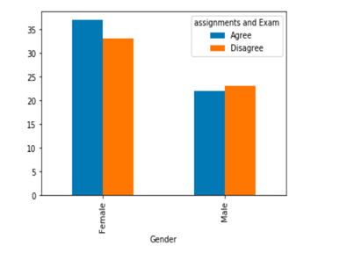

Figure 1: Satisfaction with exams and assignments for females and males in AAUP

And after analyzing the data of the satisfaction over the colleges for the assignments and exam. The figure 2 which is logical since the higher satisfaction is for the Engineering and IT which is already have online assignments during the traditional so its very logical to have higher satisfaction from the students and also the EIT students more reliable to the internet and the modern technologies than others, and the science or the sport science are very logical as well since they have practical labs that can not be done smoothly over internet.

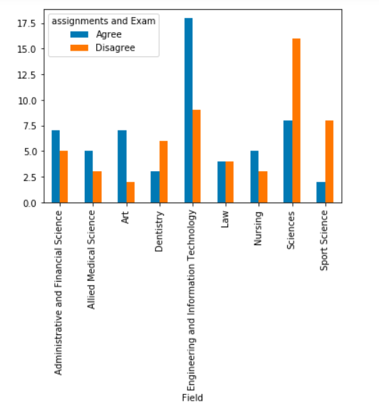

Figure 2: Satisfaction with exams and assignments within field

Part of the study , the analysis show that the student satisfaction over the assignments and exam for the students who have a GPA from (3-4 ) are more satisfied than the others which is also very logical since this category more dedicated to studies than others , the figure 3 shows the result and the effect of the GPA over the assignments and exams.

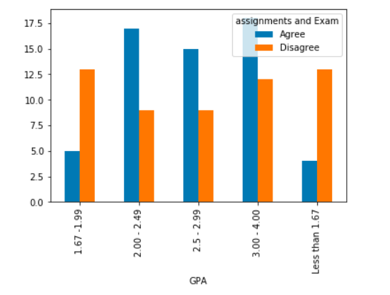

Figure 3: Satisfaction with exams and assignments within GPA

While studying the satisfaction of the students over the materials of the lectures that have been given online in the arab american university we have found the results almost equal for the females which the males results shows unsatisfied result over the online material as per the figure 4.

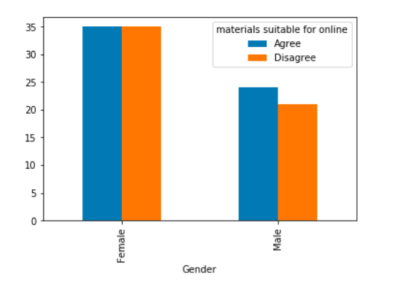

Figure 4: Satisfaction online material in Gender

Figure 5 shows the students' satisfaction over the online material based on the university registration year, the figure shows more satisfaction of the material for the early years.

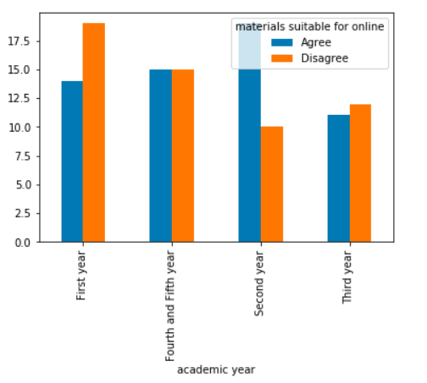

Figure 5: Satisfaction online material in Gender

Figure 6 shows the relationship between the variables that calculate the students' satisfaction over the online material based on the faculty that they study in. which show higher satisfaction for the EIT which is more logical since most of the material even with the traditional learning is online as well.

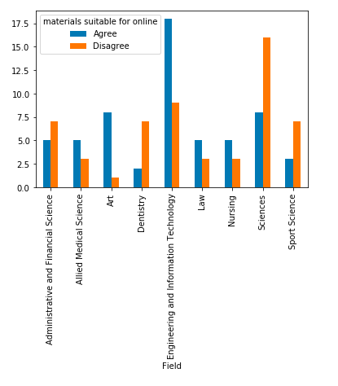

Figure 6: Satisfaction online material within field

The data shows higher satisfaction with the online teaching experience for the Engineering and IT faculty compared with others and shows the less satisfaction over the science since most of the instructors are not familiar with the modern way of lecturing using the e-learning.

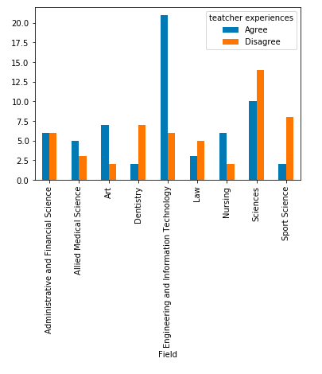

Figure 7: Satisfaction teacher experiences within field

One of the most important variable in this study was the students satisfaction over the internet speed , the results shows more satisfaction from the Engineering and IT faculty according to their experience with the internet since they are using it in daily basis in their researches , assignments and projects , also the data shows less satisfaction from the science , law and sport science since these students are dedicated to internet with high speed since they need only internet for easy and smooth things.

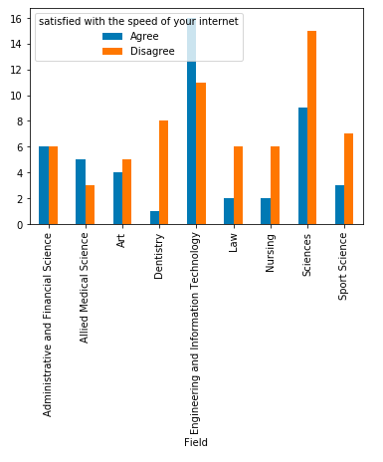

Figure 8: satisfaction over the internet speed within field

# Conclusion And Recommendations

Based on the statistics obtained, we can conclude that the transition from traditional education systems to electronic education has encountered problems and dissatisfaction among students in colleges that need more practical application within laboratories, compared to the disciplines that depend on reading.

The lesson learned from the 2020 pandemic will impose a generation of new laws, regulations, platforms and solutions for future situations, when countries, governments and people are more prepared than they are today.

The study is important for the future because it shows the state of using the free tools available to transfer traditional lectures to online education during the epidemic. Online learning needs to rearrange tests and homework for an open book concept that is not yet developed and popular. Preparing new types of these tasks in all subjects will need additional work. The problem of grades is a real problem when students remain outside the university and new techniques to combat plagiarism and avoid fraud should be considered.

When changing to online education, the ministry needs to estimate how successful the process is for the whole country or the world. Since our research covers one university, other universities must be evaluated to obtain the aggregate results for the Spring 2020 semester.so, based on our collected data and the analyzed results we suggest to have the online learning for the universities that have girls only as the result shows more satisfaction over the females. And also the online learning is very suitable for the Engineering and IT faculty and we believe that the satisfaction is more than others since the students normally have good feedback over the internet and they use the online learning in some learning activities like the projects and the assignments that have coding or research.

The future is going for the online learning especially in PAlestine according to the instability in the politics status of the country, as we know Birzeit University closed for 4 years during the first intifada so the country has to be ready for such situations so we recommend that university mush have a day weekly for the online learning for the colleges that have traditional way of teaching in order to prepare the students to the convert to e-learning for 4 years after that increasing the days for the e-learning in order to make sure that the learning process will continue whatever is the 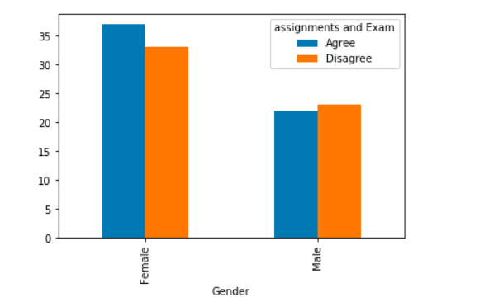social or the politics status of the country.

# Referance

[1] D. Randy Garrison; Terry Anderson; Definitions and Terminology Committee (2003). [*E-Learning in the 21st Century: A Framework for Research and Practice*](https://books.google.com/books?id=UZOG5KEoiCQC&pg=PA33&dq=define-instructional-technology). Routledge. [ISBN](https://en.wikipedia.org/wiki/ISBN_(identifier)) [978-0-415-26346-7](https://en.wikipedia.org/wiki/Special:BookSources/978-0-415-26346-7).

[2] J.A.A. Abe, Big five, linguistic styles, and successful online learning, The Internet and Higher Education (2019).

[3] David D. Curtis, Michael J. Lawson, EXPLORING COLLABORATIVE ONLINE LEARNING (2001)

[4] McBrien, J., Jones, P., & Cheng, R. (2009). Virtual spaces: Employing a synchronous online classroom to facilitate student engagement in online learning. International Review of Research in Open and Distance Learning, 10(3), 1-17.

[5] Gilbert, L. & Moore, D.R. (1998). Building interactivity into Web courses: Tools for social and instructional interaction. Educational Technology, 38(3), 29-35.

[6] Moore, M. G. (1989). Editorial: three types of interaction. The American Journal of Distance Education,3(2), 1-6.

[7] Wing S. Chow a, Si Shi, Investigating Students’ Satisfaction and Continuance Intention Toward E-Learning: An Extension of The Expectation– Confirmation Model, Procedia - Social and Behavioral Sciences (2014)

[8] Manuela Paechter, Brigitte Maier, Daniel Macher, Students’ expectations of, and experiences in e-learning: Their relation to learning achievements and course satisfaction, Computers & Education (2010)

[9] Tang and Tseng, Distance learners' information literacy skills in using digital library resources & learners' information seeking self-efficacy, (2013).